Anthony Sevarino

EET 2141

Fall ‘24

**Lab 5 Bipolar Junction Transistors – Basic Logic Circuits**

**Introduction:**

The objective of this lab is to analyze bipolar junction transistors, specifically their interactions and behaviors in basic logic circuits. Thus, a fundamental understanding of basic logic gates, such as AND, OR, and NOT gates is crucial in the undertaking of this study. Recall that a transistor is essentially some combination of diodes in opposing orientation, so this is in essence a continuation of the string of diode related studies conducted in this course. A bipolar junction transistor has three nodes, those being a collector, a base, and an emitter. These BJTs have many uses, including switching, amplifying, filtering, and oscillating.

**Bench Parts and Equipment List:**

|  |  |  |  |
| --- | --- | --- | --- |
| ***Components*** |  |  |  |
| • | 3.9kΩ, 1kΩ , 10kΩ (x2) Resistors | • | Two BJT Transistors (2N3904) |
| •  ***Equipment*** | Numerous Connector Wires |  |  |
| • | Programmable DMM | • | ELENCO Trainer Board |
| • | Triple Power Supply | • | Windows Machine w/  Multisim |

**Discussion:**

# Part 1 – The Simulation

The first step of this lab is to construct the given circuits in Multisim, the following is the provided image for each given circuit purposed toward the study of this lab

(See below)

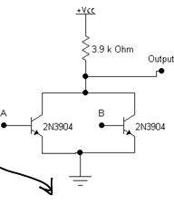

The constructed multisim circuits are as follows:



Not to be confused as one single circuit, the three circuits are connected to the same ground point. Notice that all three of the BJTs are in the same orientation, with the emitter carrying the flow of current out of the bottom.

Circuit 1 is a simple two switch, BJT series circuit with a resistor in between each switch. Circuit 2 differs from circuit 1 in the sense that there is a resistor added to the bottom of the circuit in between the second BJT and the ground. Finally, circuit 3 is the clear outlier in the sense that the BJTs are connected in parallel to one another rather than in series as seen in the previous two circuits.

The voltmeter used to conduct testing was later changed to a multimeter following the capture of these images, in other words, the voltage probes appearing in the images was no longer used.

It is clear after running the simulation that the first circuit acts as an NAND gate, meaning logically speaking, TRUE appears in every logical combination of two values except for 1-1, or TRUE-TRUE.

The second circuit, according to the simulation data, functions as an AND gate, which is the opposite of the first gate. Notice that the output is actually on the opposite end that it is in the first circuit as well. An AND gate produces logical TRUE only when the input of two logical values is 1-1, or TRUE-TRUE.

Finally, the third circuit presents as an NOR gate, where the output is logically TRUE only when its input of two values is FALSE-FALSE, or 0-0.

It is interesting to see how a BJT can turn a circuit into logic based circuit, identical to logic learned in courses such as digital systems, and the correlation between the two topics and ideals.

Below are the recorded measurements for the simulation data:

**Table 1 – Simulation Data**

|  |  |  |  |  |
| --- | --- | --- | --- | --- |
| **Logic** | | **Circuit 1**  **(V)** | **Circuit 2**  **(V)** | **Circuit 3**  **(V)** |
| 0 | 0 | 5 | 997p | 5 |
| 0 | 1 | 5 | 395m | 64.6m |
| 1 | 0 | 5 | 5.11n | 64.6m |
| 1 | 1 | 106m | 1.45 | 63.9m |

# Part 2 – The Bench

The circuit is now constructed on the bench, below are captures of each circuit constructed: (note that there are only images for circuits 1 and 3, circuit 2 is identical to circuit 1 only with a 1kΩ resistor in series with the orange ground cable at the bottom of the circuit)

Also note that the triple power supply is not used for power in this instance, instead the ELENCO trainer itself is providing the 5V of input to each circuit. The switches on this board are also being used in the circuit, and are connected offscreen with the long white and blue wires found at the top of each image.

Finally, the ground of the ELENCO trainer is also used instead of the ground located in the tirple power supply.

(See below)

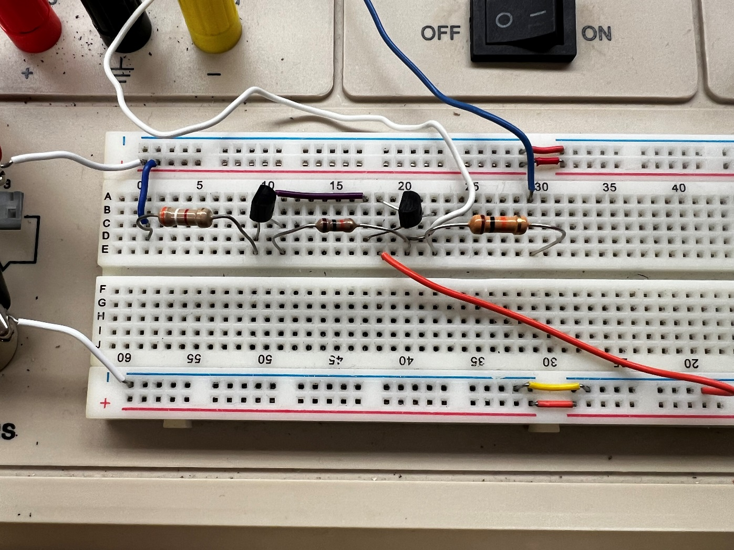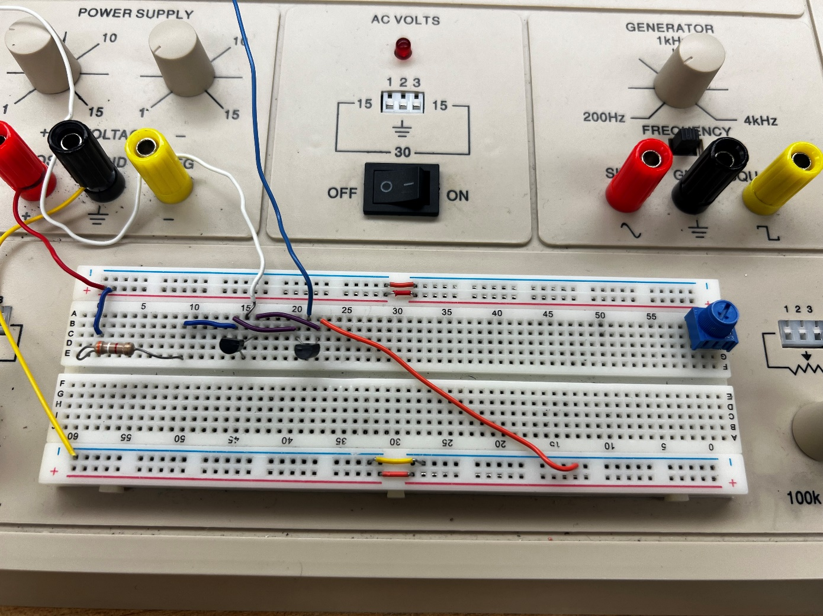

Below is an analysis of the data obtained on the bench:

**Table 2 – Bench Data**

|  |  |  |  |  |
| --- | --- | --- | --- | --- |
| **Logic** | | **Circuit 1**  **(V)** | **Circuit 2**  **(V)** | **Circuit 3**  **(V)** |
| 0 | 0 | 4.8 | 0 | 4.7 |
| 0 | 1 | 4.8 | 0.3 | 0.03 |
| 1 | 0 | 4.8 | 0 | 0.03 |
| 1 | 1 | 0 | 1.3 | 0.03 |

# Part 3 – The Comparison

Thus, it would appear that the bench measurements and simulation data both follow the same trend, and are relatively close in terms of values. Below is a graphical comparison of the two datasets:

Finally, for certification purposes, below the instructor sign-off can be found. As a reminder, this signature is obtained by either the course instructor or a certified lab assistant to ensure proper results are being obtained.

**Conclusion:**

The objective of this lab is to obtain an understanding and visualization of the behavior and purposes of BJTs in basic logic circuits, and their relation to logic learned in courses such as digital systems. The objective was met successfully as is indicated in the matching data found in the comparison graphs in section 3 of the report. Here, we can learn that BJTs are capable of turning electrical circuits into AND, NAND, OR, NOR, and any other logic based gate, making them an incredibly powerful tool in the circuits world. We also learn that a BJT is essentially a simply combination of diodes, usually in opposing orientation. If this lab were to be conducted again, it would be pertinent to include additional circuits that represent other logic based gates apart from NAND, AND, and NOR. Also, seeing a BJTs behavior against other sorts of components, such as inductors and capacitors would prove beneficial to obtaining a complete understanding as to their place in the world of electrical circuits.